Dominic Drury

05/10/2024

CS-405

1-3 Activity: Numeric Overflow Coding

Console Output from program

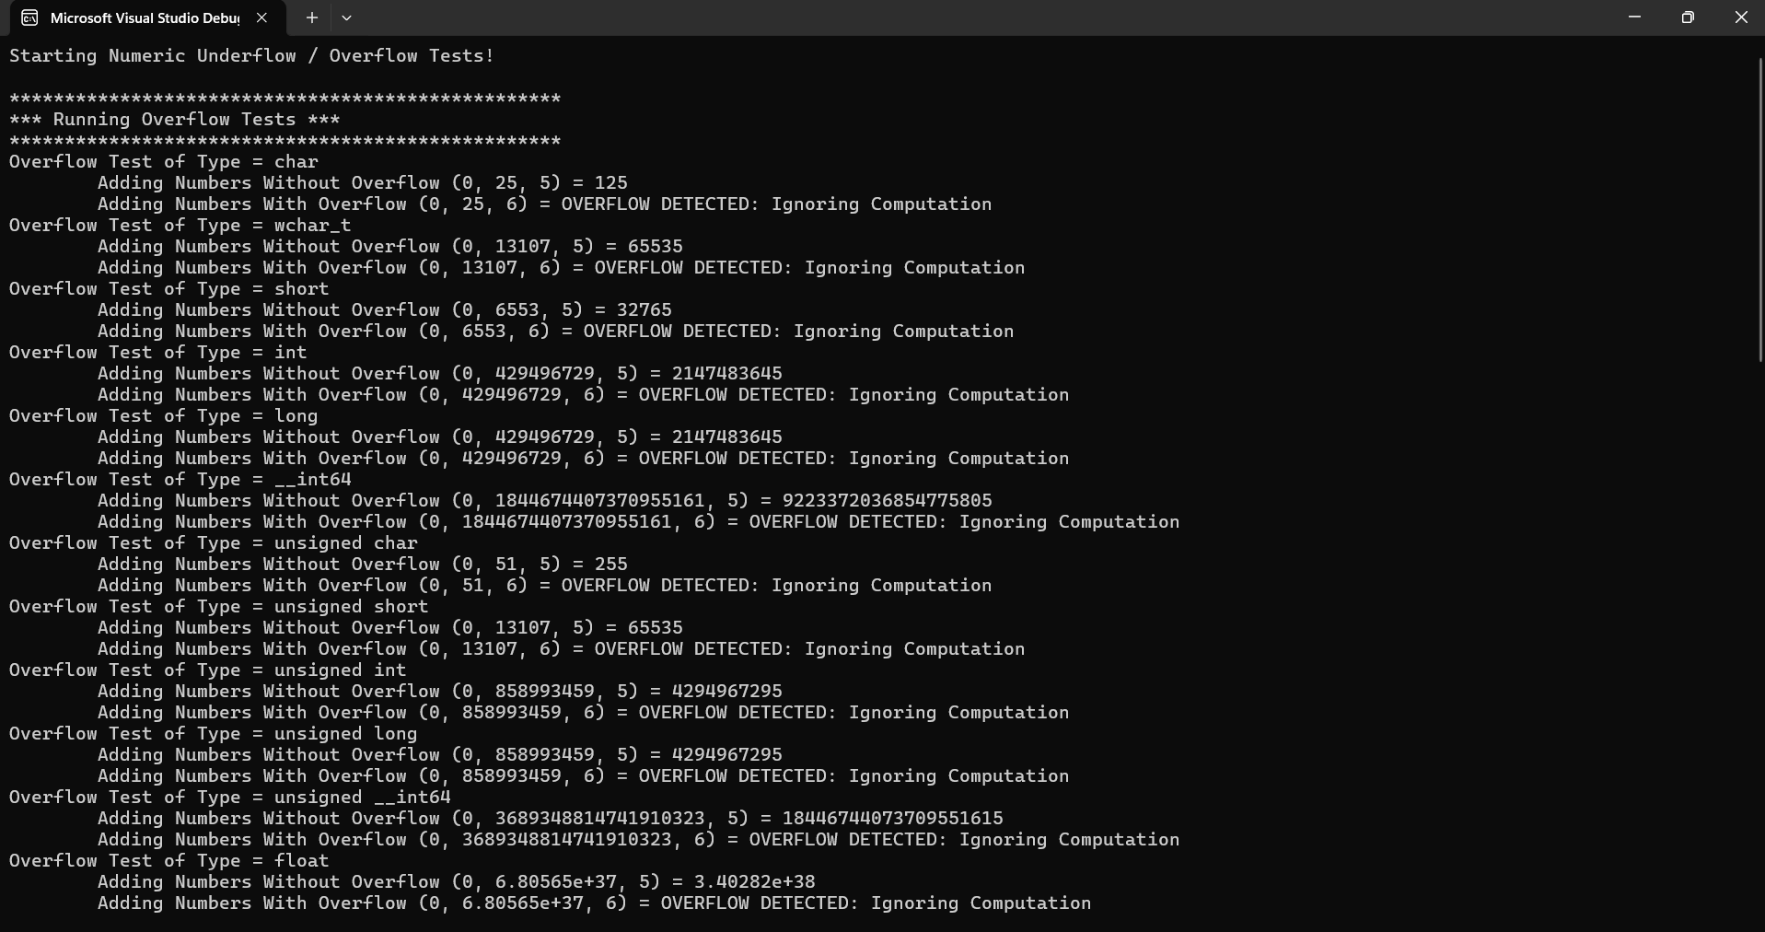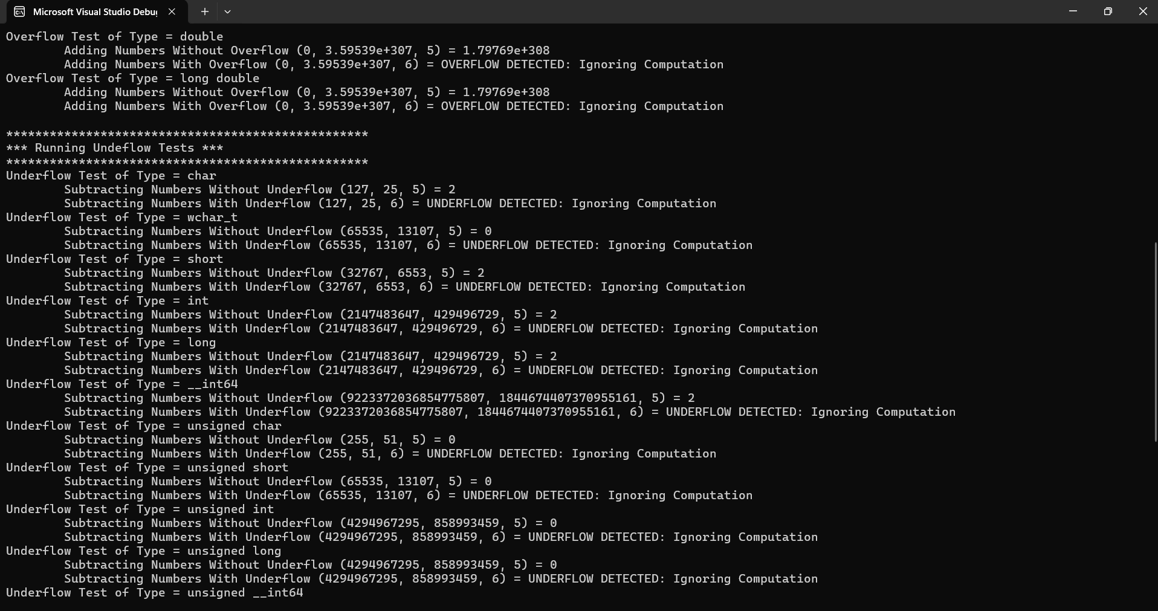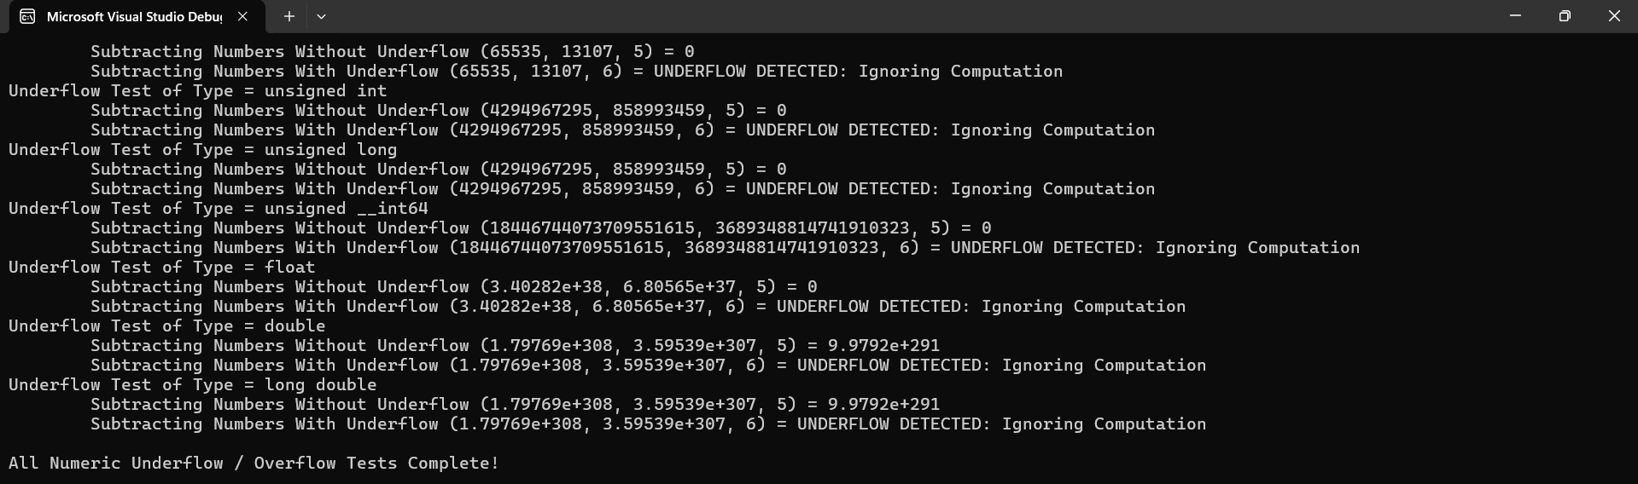

My process for completing this assignment involved a lot of running the program, seeing what overflows were still happening, and trying to check if the instance of over or underflow occurs. For example, I was able to get the basic check for overflow variables, but I was getting either both checks (with and without overflow) coming back as errors or neither throwing errors so I had to exclude them from the main check and have a seperate one that basically just checks to see if the result is above the max (which I had to check by creating inf in the check). For underflow I was having a lot of trouble with the signed types and essentially had to check them separately from the unsigned types.